POS​ System

System Analysis and Design
This document provides a comprehensive analysis and design overview of a Point of Sale (POS) system based on the diagram provided by the instructor. The system will be implemented using ASP.NET Core as the application framework and Oracle Database as the backend database system. The document explains the system architecture, modules, menu structure, database entities, and functional components.

System Diagram
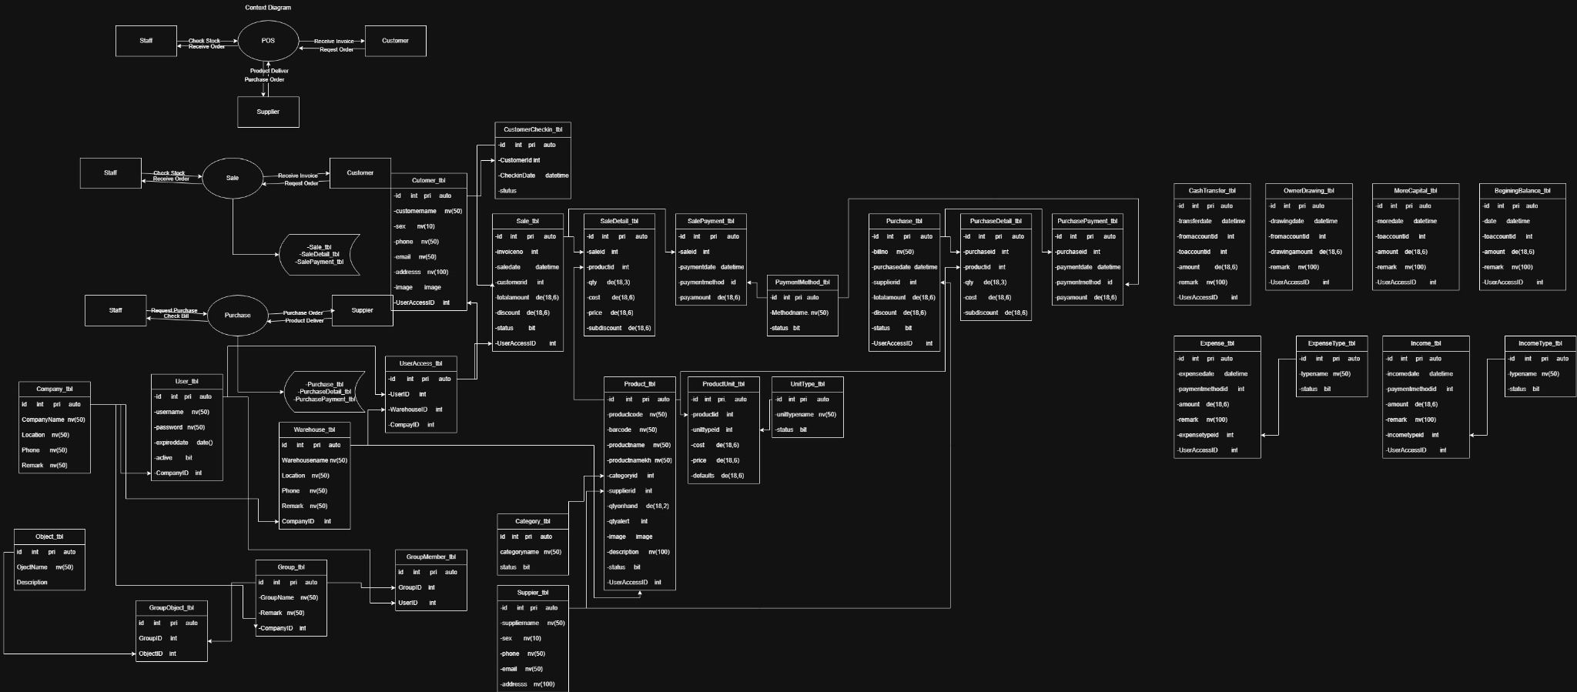

1. Introduction
A Point of Sale (POS) system is a business management system used to process sales transactions, track inventory, manage products, and record financial activities. Modern POS systems help organizations automate daily operations and improve accuracy in financial reporting.

2. System Objectives
- Provide an easy-to-use interface for sales transactions.
- Maintain accurate product and inventory records.
- Track purchases from suppliers.
- Record financial transactions such as income and expenses.
- Provide secure access control for system users.
- Generate business reports for management.

3. System Architecture
The POS system follows a three-tier architecture consisting of the Presentation Layer, Business Logic Layer, and Data Layer.
- Presentation Layer:
This layer is built using ASP.NET Core MVC or Razor Pages. It provides the user interface where staff interact with the system.
- Business Logic Layer:
This layer processes transactions, validates data, and applies business rules.
- Data Layer:
This layer uses Oracle Database to store and retrieve system data.

4. System Modules
- Dashboard Module
- Sales Management Module
- Purchase Management Module
- Product Management Module
- Inventory Management Module
- Finance Management Module
- User Administration Module
- System Configuration Module

5. Menu Structure
Main Menu | Sub Menu | Description
Dashboard | Overview | Displays system statistics including sales, purchases, and stock alerts.
Sales | POS Screen | Main interface for selling products to customers.
Sales | Sales Invoice | View and manage generated invoices.
Sales | Sales Detail | Display product items in each sale.
Sales | Sales Payment | Manage payments for sales.
Sales | Customer | Manage customer information.
Sales | Customer Check-in | Register customers before transactions.
Purchase | Purchase Order | Create purchase orders for suppliers.
Purchase | Purchase List | View purchase history.
Purchase | Purchase Payment | Record payments to suppliers.
Purchase | Supplier | Manage supplier information.
Products | Product List | Add and manage products.
Products | Category | Manage product categories.
Products | Product Units | Define product unit packaging.
Products | Unit Types | Define measurement units.
Inventory | Warehouse | Manage warehouse locations.
Inventory | Stock List | Display product stock.
Inventory | Stock Movement | Track inventory movement.
Finance | Income | Record income transactions.
Finance | Expense | Record expenses.
Finance | Cash Transfer | Transfer money between accounts.
Finance | Owner Drawing | Record owner withdrawals.
Finance | More Capital | Record additional investment.
Finance | Beginning Balance | Define starting balance.
Administration | User Management | Manage system users.
Administration | User Access | Assign system access permissions.
Administration | Group Management | Manage role groups.
Administration | Group Members | Assign users to groups.
Settings | Company | Manage company information.
Settings | System Object | Define system modules.
Settings | Group Permission | Assign module permissions.

6. Database Entity Explanation
- User_tbl – Stores login credentials and user information.
- Customer_tbl – Stores customer details such as name, phone, and address.
- Supplier_tbl – Stores supplier information used for purchasing.
- Product_tbl – Stores product data including barcode, cost price, selling price, and stock quantity.
- Category_tbl – Defines product categories.
- ProductUnit_tbl – Defines product packaging units.
- Warehouse_tbl – Stores warehouse information.
- Sale_tbl – Stores main sales transaction records.
- SaleDetail_tbl – Stores detailed product items in each sale.
- SalePayment_tbl – Stores payment information for sales.
- Purchase_tbl – Stores purchase records from suppliers.
- PurchaseDetail_tbl – Stores purchased products in each purchase.
- PurchasePayment_tbl – Stores supplier payment transactions.
- Income_tbl – Stores income records.
- Expense_tbl – Stores expense transactions.

7. User Interface Screens
- Dashboard Screen
- POS Sales Screen
- Product Management Screen
- Category Management Screen
- Purchase Management Screen
- Supplier Management Screen
- Customer Management Screen
- Warehouse Management Screen
- Income and Expense Screen
- User Management Screen

8. Expected System Benefits
- Increase transaction speed.
- Reduce human errors in calculations.
- Improve inventory tracking.
- Provide accurate financial reporting.
- Improve overall business management.

9. Conclusion
The POS system integrates sales, inventory, purchasing, and financial management into a centralized system. The use of ASP.NET Core with Oracle Database ensures scalability, security, and high performance for business operations.

